

**National Capital Region Drug Trend Mapping System**

**User Guide**

**Prepared For**

**Sgt. Pat Poitevin, RCMP**

**Professor Edmund Strange**

|  |  |
| --- | --- |
| Prepared By: | D. Marcantonio, Project Leader |
|  | L. Desjardins |
|  | E. Dube |
|  | T. Ferch |
|  | L. Morin |
|  | S. Reece |

Submission Date: Monday December 6, 2010

**List of Figures** Page

1. Landing Page 2

2. Request Membership Page 2

3. Welcome Page 3

4. Edit Settings Page 4

5. Message Centre 5

6. Entries Page 6

7. New Entries Page 8

8. Zones Page 9

9. Report Page 10

10. Report Page Options 11

11. Report Page Additional Filters Section 12

12. Report Comparison 13

13. Contributors Page 14

14. Edit Event Entry Page 15

15. Edit User Account Page 16

**Table of Contents** Page

1. Introduction 1

1.1 Features 1

1.1.1 Intuitive Navigation 1

1.1.2 Data Integrity Protection 1

1.1.3 Security 1

1.2 Requirements 1

2. Human Computer Interfaces 2

2.1 Requesting Membership 2

2.2 Logging In 3

2.3 Edit Account Settings 4

2.4 View Messages 5

2.5 Send a Message 5

2.6 View Bulletin Board Posts 6

2.7 View Existing Entries 6

2.8 Submit New Entry 8

2.9 View Zone Information 9

2.10 View a Preset Report 10

2.11 Generate A Custom Report 11

2.12 Modify Report Parameters 12

2.13 Compare Reports 13

2.14 View Contributors 14

2.15 Log Out 14

2.16 Administrator Manual 15

2.16.1 Edit an Event Entry 15

2.16.2 Edit a User Account 16

2.16.3 Delete a User Account 16

2.16.4 Delete an Event Entry 16

2.16.5 Edit Entry Information 17

2.17 Owner Manual 18

2.17.1 Change User Privileges 18

2.17.2 Installation Guide 18

**Contact Information**

* Client

Sgt./Serg. Pat Poitevin

Coordinator / Coordinateur

Drug and Organized crime Awareness Service

Service de Sensibilisation aux drogues et au crime organisé

RCMP - GRC (Division A)

155 McArthur Avenue

Ottawa, Ontario K1A 0R4

Tel: (613) 993-9380

Fax: (613) 998-7358

e-mail / Couriel: pat.poitevin@rcmp-grc.gc.ca

* Project Group Members

David Marcantonio, Project Leader

davidmarcantonio@gmail.com

Luc Desjardins

Luc.r.desjardins@gmail.com

Eric Dube

Ericdube88@gmail.com

Tom Ferch

Tom.h.ferch@gmail.com

Luc Morin

MorinLuc0@gmail.com

Sean Reece

Reece.sean@gmail.com

* Project Professor

Edmund Strange

Algonquin College – Woodroffe Campus

Computer Studies Department

1385 Woodroffe Avenue

Ottawa, Ontario

K2G 1V8

(613) 727-4723 ext. 3483

strange@algonquincollege.com

# Introduction

The National Capital Region Drug Trend Mapping System (NCRDTMS) was developed to help community partners identify trends in drug use in zones across the National Capital Region (NCR). Community partners input entries of drug usage events, and the NCRDTMS generates reports based on these anecdotal entries to display broad trends in drug use to aid police and community partners in focusing awareness efforts.

**1.1 Features**

The NCRDTMS provides features to users and administrators of the system enabling ease of use, data integrity protection, and security. The NCRDTMS has the following specific features:

**1.1.1 Intuitive Navigation**

The NCRDTMS allows users to navigate the system as a website with a standard interface. The primary navigation interface is the Navigation Bar displayed across the top of every page. This navigation bar is designed to provide a simple, intuitive way of accessing the desired part of the system.

**1.1.2 Data Integrity Protection**

The NCRDTMS is designed to ensure data is able to be correlated by having users enter data in dropdown menus. When a truly new datum needs to be entered, the user has the ability to fill in a “new” entry, with a warning to double check the entry does not already exist. The NCRDTMS allows administrators to remove entries in the event that an error or duplication does occur.

**1.1.3 Security**

The NCRDTMS is designed to ensure that only approved community partners have access to the data. While no personally identifying information is stored in the system, the data is not intended to be released to the public. The system provides a mechanism for community partners who wish to contribute to request approval from the administrator.

**1.2 Requirements**

In order to use the NCRDTMS, you require a computer or other device capable of accessing the Internet on a modern browser, such as Internet Explorer 7 or higher, Firefox 3 or higher, or Google Chrome.

# Human-Computer Interfaces (HCIs)

**2.1 Requesting Membership**

1. In your web browser address bar, enter the address of the NCRDTMS (note: to be determined).

2. When the website loads, you will be presented with the Landing Page:

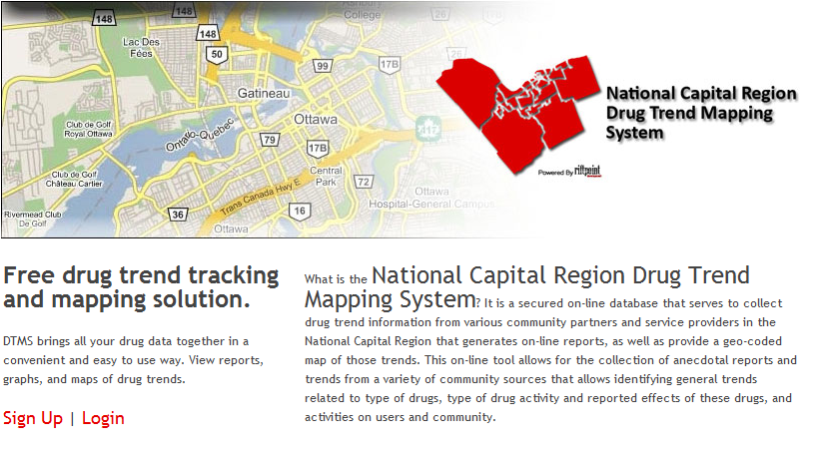

Figure 1: Landing Page

1. Click the “Request Membership” link under the Login Text Fields.
2. You will be presented with the Request Membership Page:

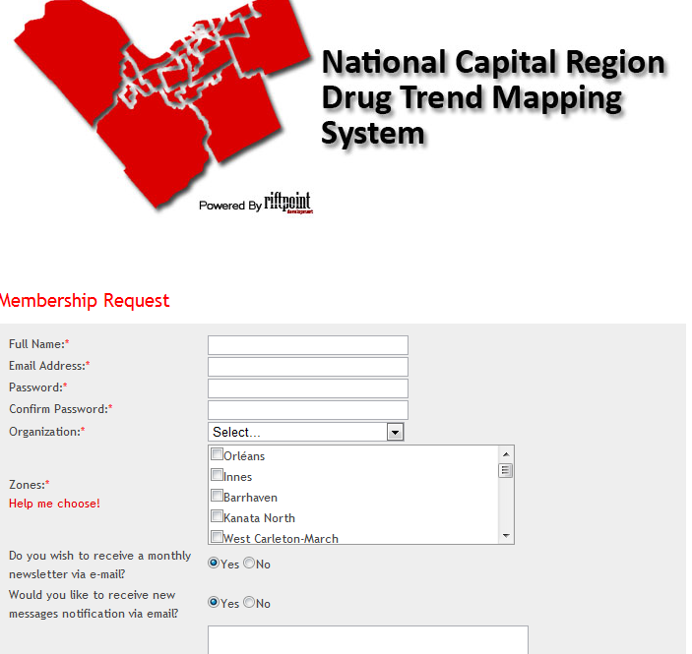

Figure 2: Request Membership Page

1. Fill in your e-mail address, full name, and organization, and a password, and check “Yes” if you wish to receive a monthly newsletter or “No” if you do not. Select whether you wish to receive Zone, Organization, and Bulletin messages as email.
2. If you wish, write a comment which will be sent to the Administrator with your Membership Request.
3. Click “Submit” at the bottom of the page. A request will be sent to the Administrator(s), and you will be notified by e-mail when your request has been accepted or denied.

**2.2 Logging In**

1. In your web browser address bar, enter the address of the NCRDTMS (note: to be determined).

2. When the website loads, you will be presented with the Landing Page (see Figure 1).

3. Click "Login" to go to the Login Page.

3. To log in, enter the email address you are registered under into the Email box, and your password into the password box, then click the “Log In” button.

4. On logging in, you will be presented with the Welcome Page:

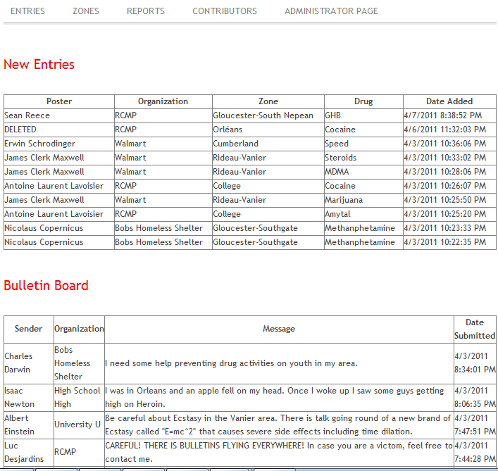

Figure 3: Welcome Page

This page will display entries that have been submitted since your last visit and the 5 most recent bulletins.

**2.3 Edit Account Settings**

1. Log On to the System (see 2.2).

2. Click "edit account" at the top right to go to the account settings page:

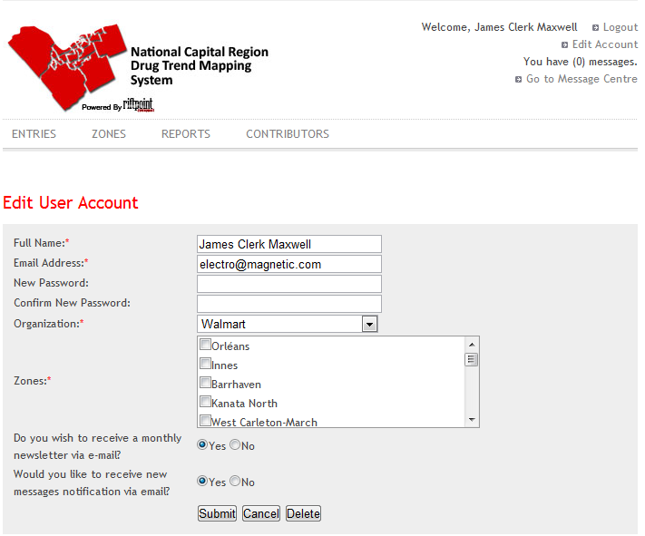

Figure 4: Edit Settings Page

3. Fill in the text boxes of each field you wish to update, then click the "save changes" button to submit the changes.

**2.4 View Messages**

1. Log On to the System (see 2.2).

2. Click the “Go to Message Centre” link at the top right to go to the Message Centre:

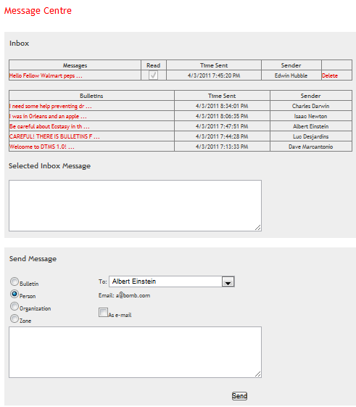

Figure 5: Message Centre

3. The messages will be listed by Sender and Subject in a box at the top of the page. Click on a message in the list to view the full text of the message.

**2.5 Send a Message**

1. Log On to the System and go to the Message Centre (see 2.4).

2. In the Send Message area under the Inbox (see Figure 3), select whether the message is to be sent as a global bulletin, to a specific person, to all members of a particular organization, or to all users associated with a specific Zone.

3. If you picked a message type other than Bulletin, select the Contributor, Organization, or Zone from the "To:" dropdown box.

4. If the message is time-critical, check the "as email" box to send the message as an email. (Note: Please refrain from using "as email" except in the event of critical messages.)

4. Type the content of your message into the message area.

5. Click "Send" to send the message.

**2.6 View Bulletin Board Posts**

1. Log On to the System and go to the Message Centre (see 2.4).

2. Scroll down to view the Bulletin Board area under the Inbox area (see Figure 3.) The most recent bulletins will be displayed here.

**2.7 View Existing Entries**

1. Log On to the System (see 2.2).

2. Click the “Entries” link in the navigation bar to go to the Entries Page:

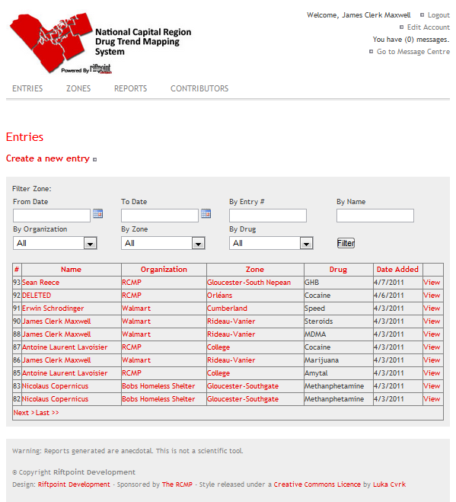

Figure 6: Entries Page

3. If desired, select start and end months and years to display only entries submitted between those dates.

4. If desired, select an Organization, Zone, or Drug to view only entries applicable to that descriptor.

4. The displayed entries can be sorted by any field by clicking the header of that field. Click the header again to reverse the sort order.

5. Click "view" to the right of any Entry for a detailed view of that Entry.

**2.8 Submit a New Entry**

1. Log On to the System and navigate to the Entries Page (see 2.7).

2. Click the “Create a new Entry” link to go to the New Entry Page:

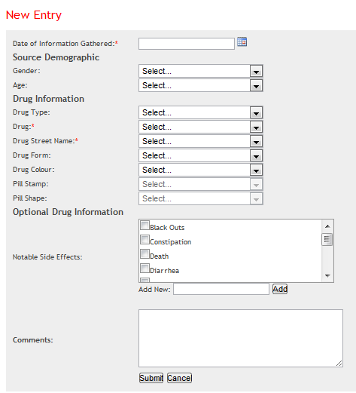

Figure 7: New Entry Page

3. Fill in at least the estimated date of the event, and the Drug and Street Name used in the appropriate dropdowns.

4. If you are associated with more than one Zone, also choose which Zone the event applies to in the Zone dropdown.

5. Fill in any of the other fields known from the dropdown controls.

6. If the event involved an item which does not appear, select the "Other" option on that dropdown and fill in the datum manually in the textbox which appears. Note: Please double check that an appropriate option is not in the list under another name before entering a new option.

7. Check any side effects that apply.

8. Fill in any additional comments on the event in the comments field.

9. Click the “Submit Entry” link to save the entry and submit it to the NCRDTMS.

**2.9 View Zone Information**

1. Log On to the System (see 2.2).

2. Click the "Zones" link in the navigation bar to go to the Zones Page:

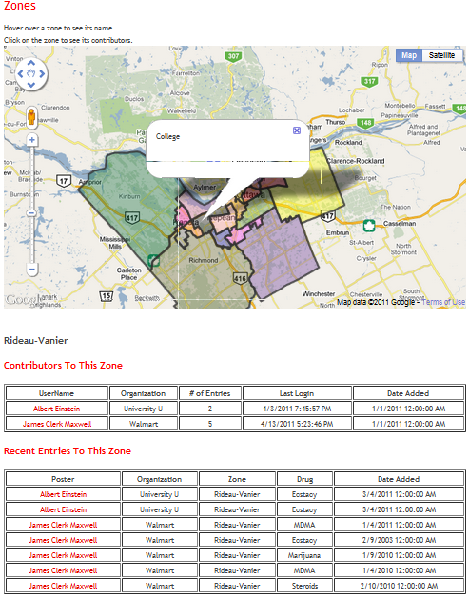

Figure 8: Zones Page

3. The page will display the master map of the National Capital Region.

4. Hover over a zone on the map to display the zone name tooltip.

5. Click on a zone on the map. Detailed information on the zone will be shown under the map: first, a list of the Contributors associated with the zone. Second, a table of recent entries for the Zone will be displayed under the contributors list.

**2.10 View a Preset Report**

1. Log On to the System (see 2.2).

2. Click the “Reports” tab in the Navigation Bar to get to the Reports Page:

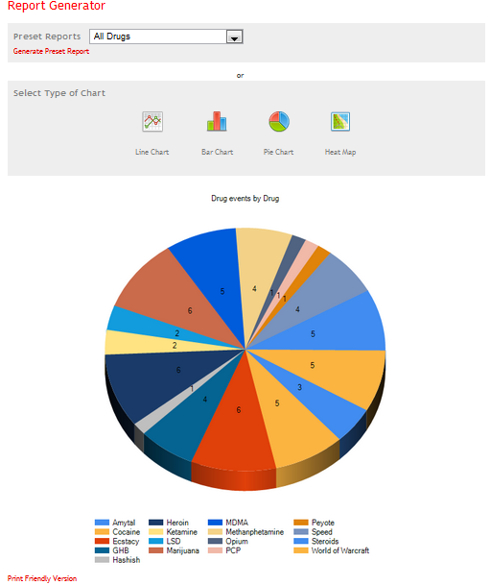

Figure 9: The Report Page

3. Select one of the Preset Reports from the dropdown list.

4. Click the "Generate Preset Report" link under the dropdown.

5. The report will be created and displayed under the report parameters area.

**2.11 Generate a Custom Report**

1. Log On to the System (see 2.2) and go to the Reports Page (see section 2.10).

2. Click one of the Chart Type images to select that Chart.

Note: The Heat Map is always displayed as a Print-Friendly Version. See 2.13.

3. Select the Field to compare by. This is the field that will form one axis of the chart:

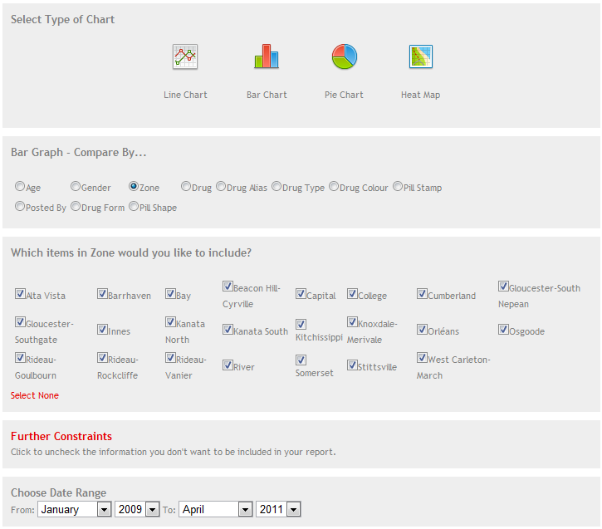

Figure 10: Report Page Options

4. Select which items in that Field to include, or click "Select All" to check all the boxes (and uncheck any you wish not to include.)

5. If desired, click the "Further Constraints" button to open the additional constraints panel and add additional filters. All of the advanced filters default to include all possible information.

6. Select the start and end dates for the data to be compiled in the report from the appropriate dropdowns.

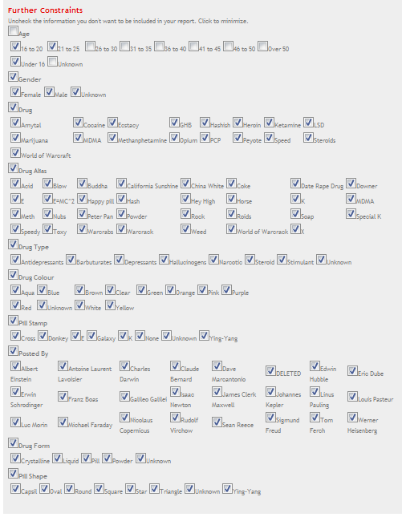

Figure 11: Report Page Additional Filters Section

7. Click “Generate Report.” The report will be created and displayed under the report parameters area.

**2.12 Modify Report Parameters**

1. Log on to the system and generate a report (see section 2.10).

2. The report parameters area will still be present over the generated report. Change any of the report parameters desired and click “Generate Report” again to view the report with the modified parameters.

**2.13 View Print Friendly Report**

1. Log on to the system and generate a report (see section 2.10).

2. Click the “View Print Friendly Version” button under the Chart.

3. You will be redirected to the print-friendly version page:

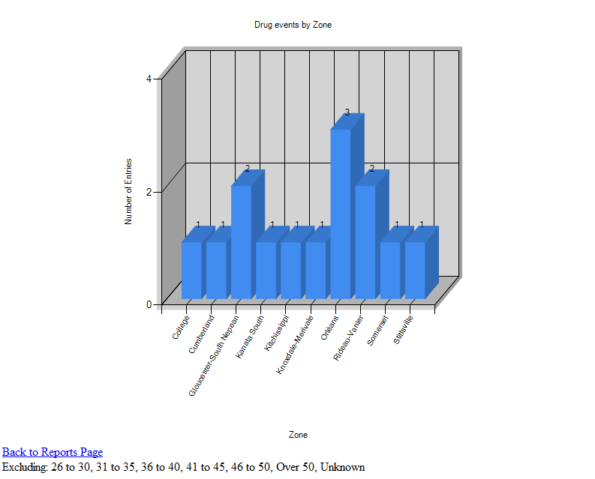

Figure 12: Report Comparison

4. This version of the report does not display the DTMS site header and navigation bar, and the text is unformatted. This makes it a cleaner, more elegant version to save or print to view later. The print friendly version can also be shared with another contributor by copying the URL in the Address Bar and sending it to them in a message or email.

5. If desired, click "View" for any Entry in the Included Entries View. This will show the detailed view of that Entry. Click the Back button in your browser to return to the Print Friendly Report.

6. When finished, click "Back to Reports Page" or the back button in your browser to return to the Reports Page.

**2.14 View Contributors**

1. Log On to the System (see 2.2).

2. Click the “Contributors” tab in the Navigation Bar to get to the Contributors Page:

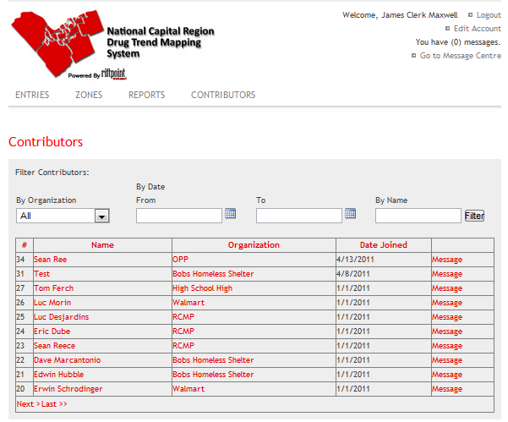

Figure 13: Contributors Page

3. The list of all contributors will be shown in the content area.

4. If desired, select an Organization from the Organization Filter drop down to view only contributors from that Organization, select dates in the From and To calendar controls to view only Contributors who joined between those dates, or type a name and click "Filter" to search for a contributor of that name.

5. Click on any heading in the contributors table to sort by that field. Click again to reverse sort. 6. To view details on a contributor, click on that contributor in the table.

7. To send a contributor a message, click the "Message" link on the right of the table, or follow the steps described in Section 2.5.

**2.15 Log Out**

1. From any page on the system, click “Sign Out” at the top right to log off. Your session will be ended and you will be returned to the Login Page.

**2.16 Administrator Manual**

When logged on as an Administrator, the site can be navigated in all ways a user can (See Sections 2.1 to 2.15), but additional functionality appears, as follows.

**2.16.1 Edit an Event Entry**

1. Go to the Event Entries Page and navigate to the detail view for that Entry(see Section 2.7).

2. An "Edit" link will appear at the bottom of the Entry View. Click this link to go to the Edit Entry page for that entry:

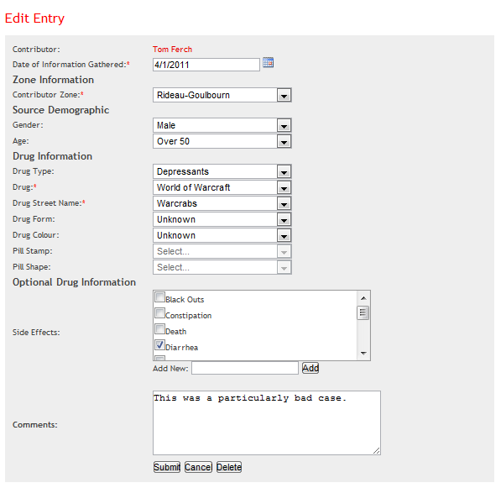

Figure 14: Edit Event Entry Page

3. This page will appear much like the "Submit New Entry" page, with the fields filled in as they were by the submitting contributor.

4. Correct any errors found.

5. Click "Submit" to confirm the changes to the entry, or "Cancel" to return to the Entry View page without saving.

**2.16.2 Edit a User Account**

1. Go to the Contributors page (see Section 2.14).

2. An "Edit Account Information" link will appear to the right of each row in the table. Click this link to go to the Edit Account page for that Entry:

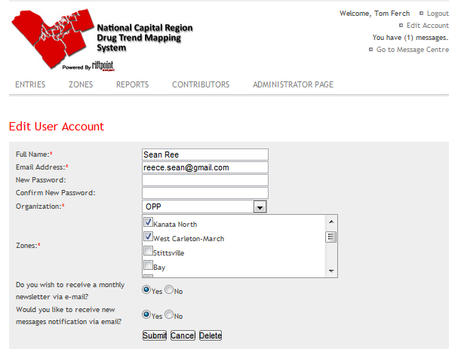

Figure 15: Edit User Account Page

3. This page will appear as the Account Settings Page, with an additional section to change the zone associations of the selected user.

4. Make any desired changes.

5. Click "Submit" to change the account settings, or "Cancel" to return to the contributors page without saving.

**2.16.3 Delete a User Account**

1. Go to the Contributors page and Edit that User(see Section 2.16.2).

2. A "Delete " link will appear at the bottom of the Contributor View.

3. Click this link and a confirmation dialog will appear.

4. Click "Yes" to delete the user account, or "No" to cancel.

**2.16.4 Delete an Entry**

1.Go to the Event Entries Page and edit an Event.

2. At the bottom of the Entry View a Delete button will appear.

3. Click this link and a confirmation dialog will appear.

4. Click "Yes" to delete the entry, or "No" to cancel.

**2.16.5 Edit Entry Information**

1. Click the "Administrator Page" link which appears at the right of the Navigation Bar to get to the Admin Page:

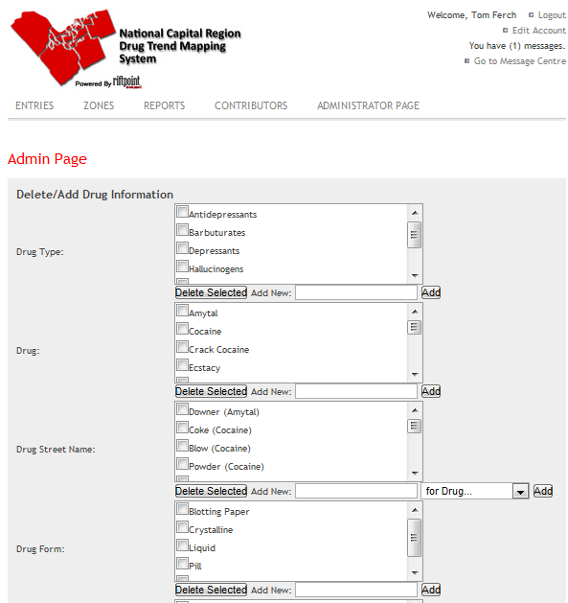

Figure 16: Administrator Page

2. This page will display the items currently available for each Field in an Entry.

3. Find any items which are incorrect, select them, and click the "Delete Selected" button under that list.

4. A confirmation dialog will pop up. Click "Yes" to delete those items or "No" to cancel.

5. You may also add new items by typing them into the "Add New" field and clicking "Add."

**2.17 Owner Manual**

When logged on as the Owner, the site can be navigated in all ways an Administrator can (See Section 2.14), but additional functionality appears, as follows.

**2.17.1 Change User Privileges**

1. Go to the Edit Contributor page for the account you wish to change(see Section 2.16.2).

2. A "User Privileges" dropdown will appear along with the other options in the Contributor View. Select a Privilege Level for the account and click "Submit" at the bottom of the View.

3. A confirmation dialog will appear, click "Yes" to save the change or "No" to cancel.

**2.17.2 Installation Guide**

1. The DTMS site requires that the Microsoft IIS service is running on the server it is installed to.

2. The Web.config file must be modified with the appropriate settings:

1. The "ChartImageHandler" key must include a "dir=some\valid\directory\;" entry in the value. This directory must exist, and it must be both readable and writable by the DTMS process.

2. The value associated with the "OwnerEmail" key must be the email address of the primary owner. This is the email address membership requests will be sent to.

3. The value associated with the "SystemEmail" key must be the email address of the system. This is the address from which membership requests will be sent to the owner.